AZURE ASSIGNMENT

Resource group:

* Resource group is nothing but the collection of resources.
* It is a platform where we can place all the resources for a particular application

Virtual network:

* Whatever the resources are running or created that should be in our control.
* So, we are creating virtual network.
* Short form of virtual network is Vnet.
* If we want to launch the virtual network, we must create default subnet.

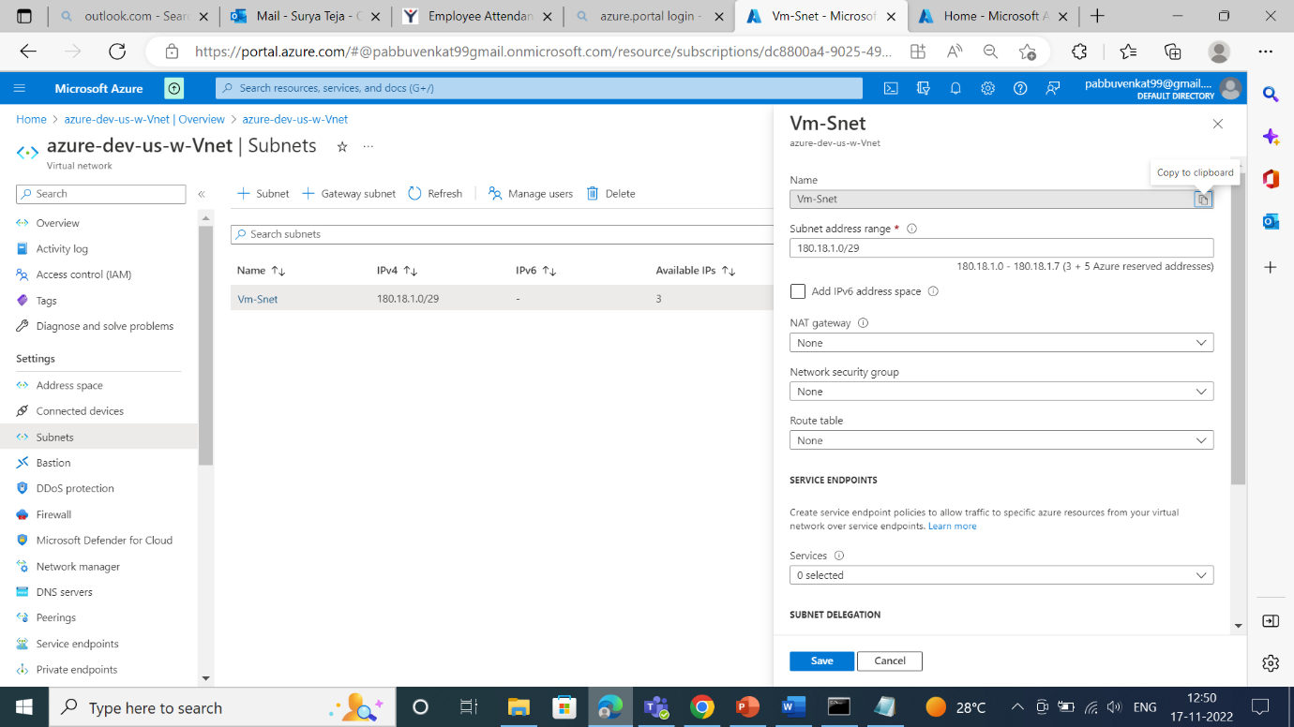

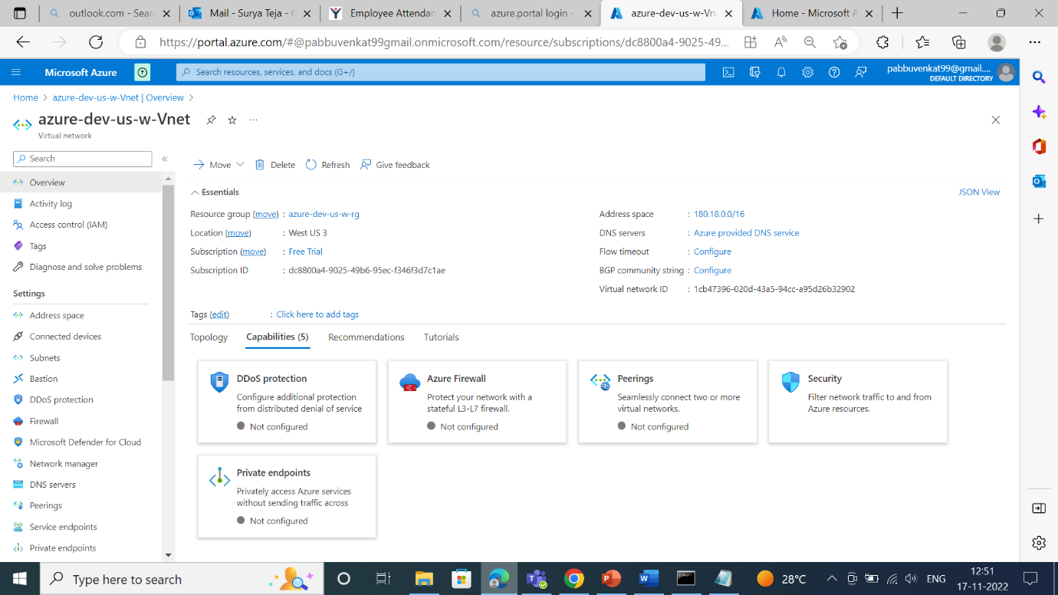

Azure Kubernetes services:

* To deploy our micro services.
* Instead of maintaining huge application we are maintaining it into multiple manageable services. (Micro services)
* We are creating the AKS subnet i.e, how many ips are needed to assign in AKS cluster and it is depending upon the micro services we deploy.

* We must install the AZ-CLI and kubeCTL.
* AZ-cli is used to manage many azure devops services from the command line.
* KubeCTL is a command line tool, and it is used to communicate and control Kubernetes clusters.
* We are deploying the Kubernetes cluster and connecting the cluster and creating the name spaces using AZ-cli and kubeCTL.
* We must connect through azure portal

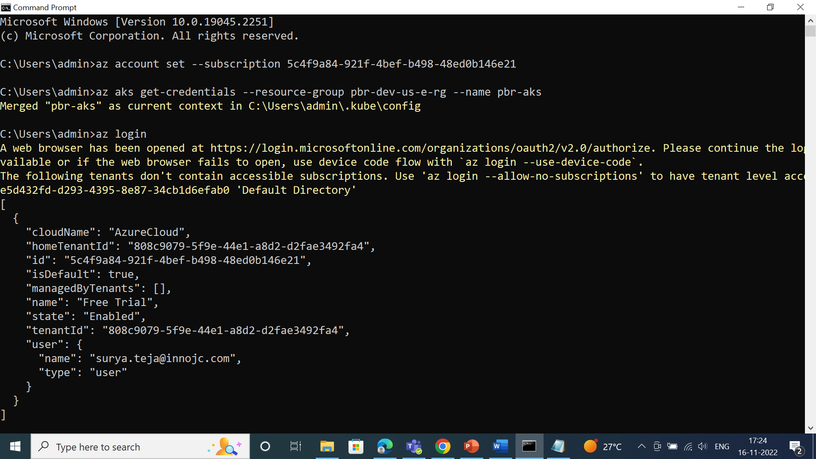

* Deploying the azure Kubernetes cluster

* After login into aks cluster the config file will be generated.
* Config file contains secured data and token information, and it will be generated with the help of client certificate data, client key data and token.

* When we launch AKS cluster by default, we get namespaces.
* Namespaces is nothing but organize cluster into virtual sub-clusters.
* Deploying the pods, pod is a small scale of deployment nothing but small program with the help of this we can deploy all our services.
* Commands >kubectl get namespaces

>kubectl get pods

* We should not deploy services in default namespaces because due to security.

To create namespace command

>kubectl create ns surya

>kubectl get namespaces

To know the pod

>kubectl get pod -n myapp

To describe the whole pod information

>kubectl describe pod hello1 -n myapp

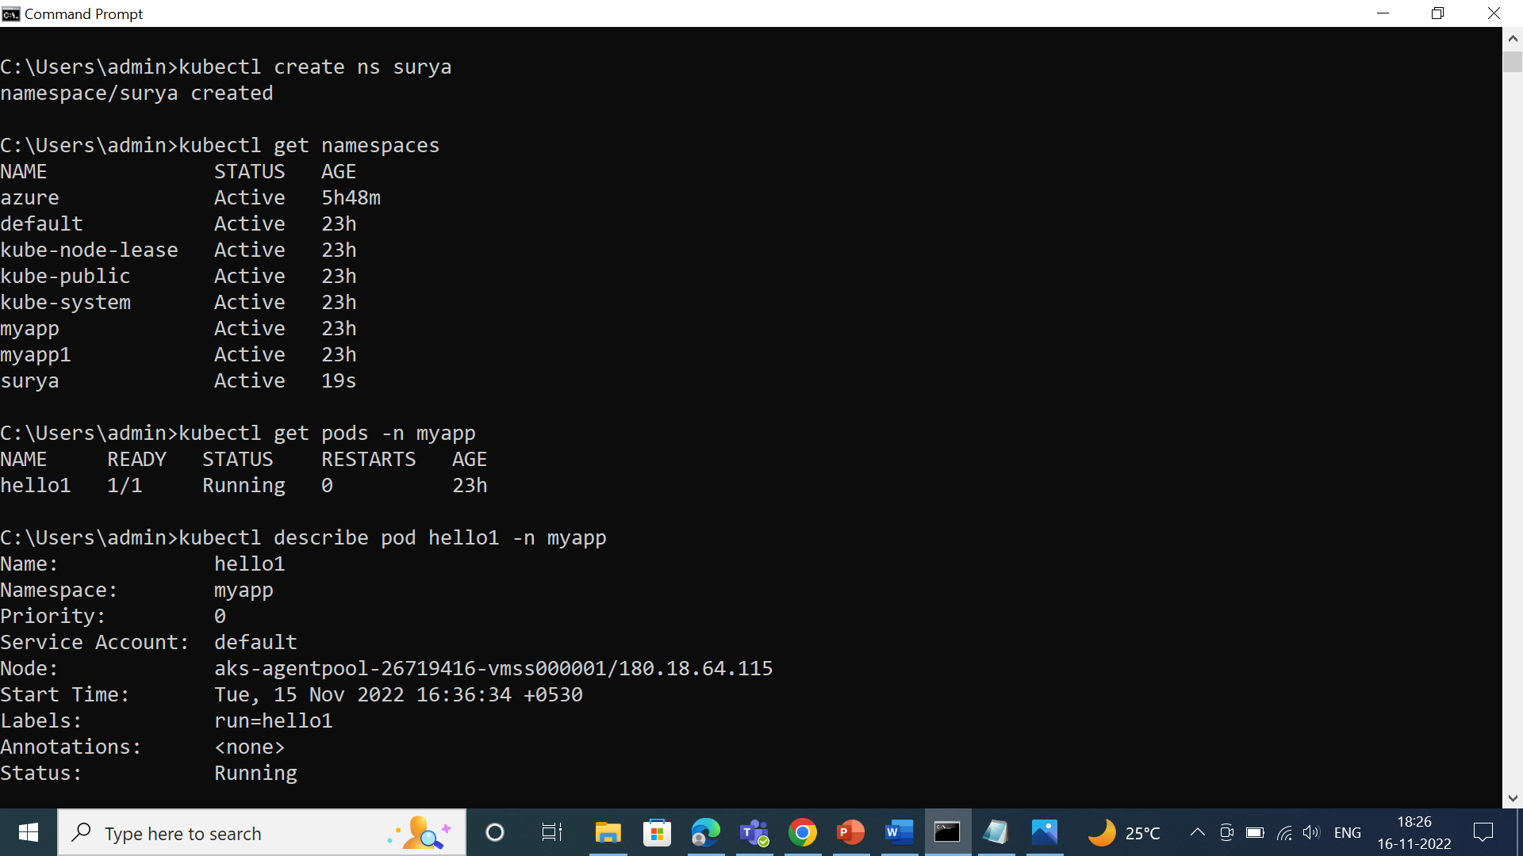

To know the deployment and services

>kubectl get deployment

>kubectl get services

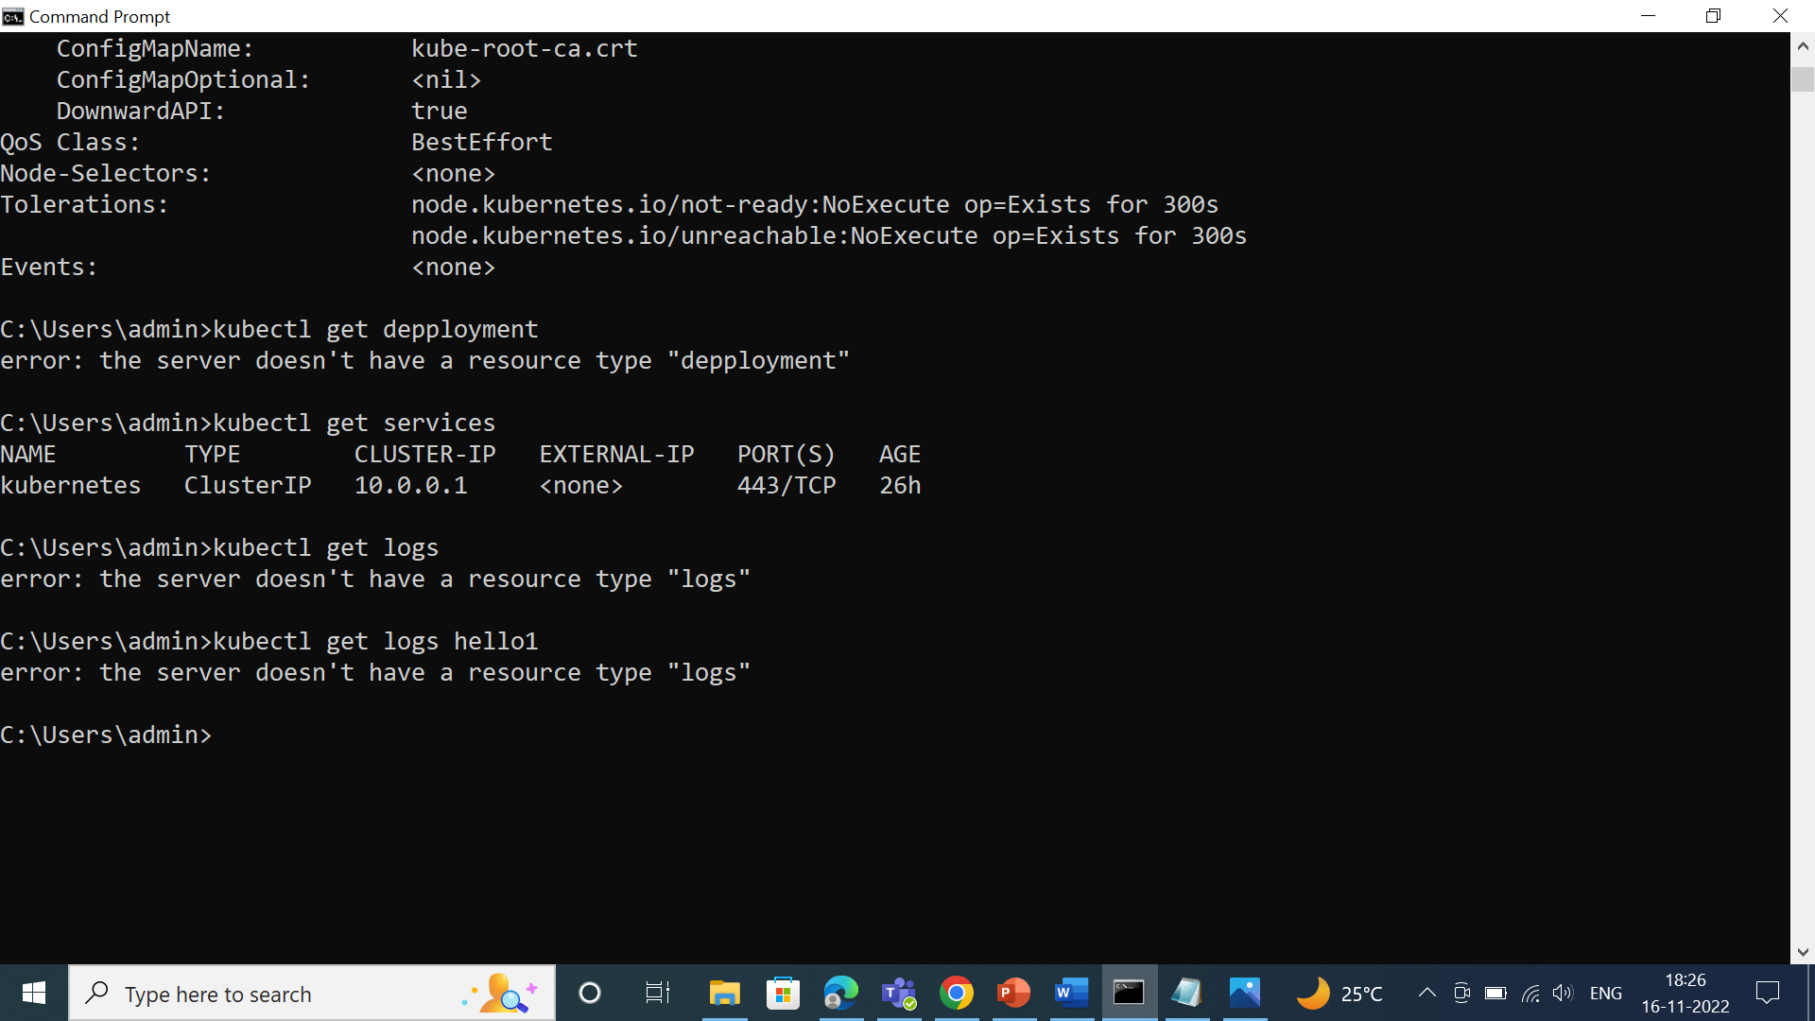

ACR (azure container registry):

* Azure container registry is nothing, but we place image or to maintain the image in public cloud.
* In real time we are going to create repository and we are placing the image in the repository.
* If we want to send the image from on premise to public cloud, we have to install AZ CLI.
* We need to provide access to the AKS subnet because to pick up the image and to deploy the service.

Key vault:

* With the help of key vault, we can able to secure the sensible information.
* Azure key vault is a cloud service that provides a secure store for secrets.
* We can securely store keys, passwords, certificates,and other secrets.

We can create and manage key vault through azure portal.

Azure Active Directory (AAD):

* AAD is a Microsoft enterprise cloud-based identity and accesses management (IAM) solution.
* Azure AD is the backbone of 365 system.
* For an organization azure AD helps employee’s signup to multiple services and accesses them anywhere over the cloud with a single set of login credentials.

* In real time we are giving the group level access and individual, now we are creating the group in azure active directory.
* Azure group is the name of the group in azure AD.

* Owner (Surya) only can read, contribute and modify the group nothing but managing now we are adding members to the group.

* Now, we are giving access in resources like: APIM, AKS, virtual network and whatever the resources we are created.
* We are giving READ and CONTRIBUTE access in API resource.
* READ - View all resources but not allow to make CONTRIBUTE – Manage all the resources and can make changes.

